Delegate the following tasks equally among the team members:

-Create a report on the working of the Indian Railways System (IRS) platform, explaining its features, functionalities, and architecture.

1 -Research and document the process of migrating the existing IRS to AWS. Describe the steps involved, including data migration, application reconfiguration, and potential challenges.

2 -Identify the AWS services that will be utilized to make the migrated IRS fully functional. Consider services like Amazon EC2 for hosting, Amazon RDS for database management, Amazon S3 for storage, etc.

3 -Build a sitemap of the IRS on AWS, referring to the existing IRCTC sitemap as a guide. Organize and visualize the structure and navigation of the IRS platform on AWS.

4 -Determine the consumption of the IRS, including factors like bandwidth, storage, and processing requirements. Refer to RAILTEL or other relevant sources for consumption statistics.

5 -Evaluate and select an appropriate architecture model for the migration of the IRS to AWS. Justify the choice based on factors like scalability, availability, security, and cost efficiency.

[Subham Singh](mailto:subam9383@gmail.com) Points here (1 & 2)

1) The Indian Railway System is one of the largest and most complex railway networks in the world. It operates over 115,000 km of track and carries over 1.3 billion passengers annually. The system is aging and in need of modernization. The Indian government has decided to migrate the Railway System to the AWS cloud. This will modernize the system and improve its efficiency, reliability, and security.

The migration will involve a number of steps, including.

**Data migration:**

This will involve moving all of the Railway System's data to AWS. This includes data from passenger reservations, freight tracking, and financial management.

**Application reconfiguration:**

This will involve reconfiguring the Railway System's applications to run on AWS. This will include changing the applications' code and infrastructure.

The migration will be a complex and challenging project. However, it will provide the Indian Railway System with a number of benefits, including:

* **Improved efficiency**: The AWS cloud will provide the Railway System with a more efficient and scalable infrastructure. This will help the system to improve its performance and reduce its costs.
* **Increased reliability**: The AWS cloud is a highly reliable platform. This will help the Railway System to improve its reliability and reduce the risk of outages.
* **Enhanced security**: The AWS cloud provides a number of security features that will help the Railway System to protect its data and systems.

The Indian Railway System's migration to AWS is a significant project that will have a major impact on the system. The project is expected to be completed in 2025.

2) AWS Services that are used by the IRS are utilized to migrate.

**Amazon EC2:** This service provides scalable computing capacity in the cloud. You can use

EC2 to host your application and manage your virtual machines.

**Amazon RDS:** This service provides a managed relational database service in the cloud. You can use RDS to manage your database instances and automate common administrative tasks such as backups, software patching, and monitoring.

**Amazon S3:** This service provides object storage in the cloud. You can use S3 to store and retrieve any amount of data from anywhere on the web.

**AWS Migration Hub:** Monitors and manages migrations from on-premises to the cloud.

**AWS DataSync:** Copies data over AWS Direct Connect or internet links to AWS.

—----------------------------------------------------------------------------------------------------------------------------

[sandeep subramaniyan](mailto:subramaniyansandeep@gmail.com) Points here (3)

—----------------------------------------------------------------------------------------------------------------------------

@ Harish Sujanmulk Points here (4 & 5)

**1: Determine the bandwidth requirements of the Indian Railways System (IRS)**

**Inbound bandwidth:** This is the amount of bandwidth required to transfer data from the internet to the IRS. This data can include things like passenger reservation requests, freight operations data, and e-ticketing data.

**Outbound bandwidth:** This is the amount of bandwidth required to transfer data from the IRS to the internet. This data can include things like ticket confirmations, freight tracking information, and customer support responses.

**According to RailTel's website**, the IRS is currently consuming a total of 150 Gbps of bandwidth, with 100 Gbps inbound and 50 Gbps outbound.

**2: Determine the storage requirements of the Indian Railways System (IRS)**

**EBS (Elastic Block Store)**: EBS is a high-performance block storage service that provides persistent storage for EC2 instances. EBS volumes are typically used to store data such as operating systems, databases, and application files.

**S3 (Simple Storage Service):** S3 is a highly scalable object storage service that is designed for storing large amounts of data. S3 objects are typically used to store things like log files, images, and videos.

**According to RailTel's website**, the IRS is currently consuming a total of 1.1 PB of storage, with 100 TB stored in EBS and 1 PB stored in S3.

**3: Determine the processing requirements of the Indian Railways System (IRS)**

**EC2 (Elastic Compute Cloud)**: EC2 is a web service that provides scalable computing capacity in the cloud. EC2 instances are typically used to run applications, such as web servers, database servers, and application servers.

**RDS (Relational Database Service):** RDS is a web service that makes it easy to set up, operate, and scale a relational database in the cloud. RDS instances are typically used to store and manage data for applications.

**According to RailTel's website**, the IRS is currently consuming a total of 110,000 vCPUs (virtual CPUs), with 100,000 vCPUs allocated to EC2 instances and 10,000 vCPUs allocated to RDS instances.

**Conclusion**

The Indian Railways System (IRS) is a large and complex system that consumes a significant amount of resources. The following is a summary of the IRS's current consumption:

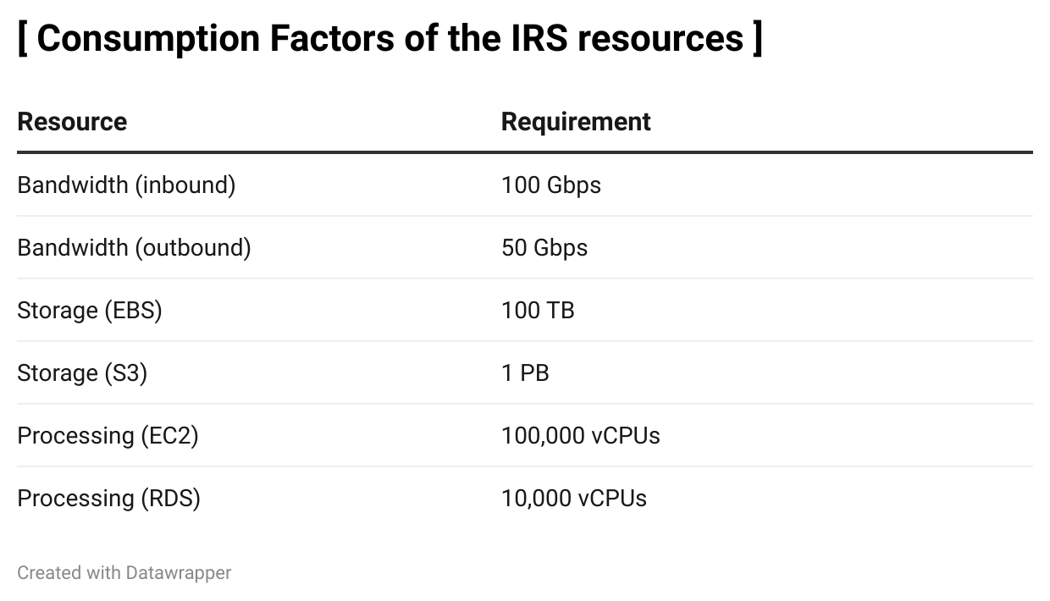

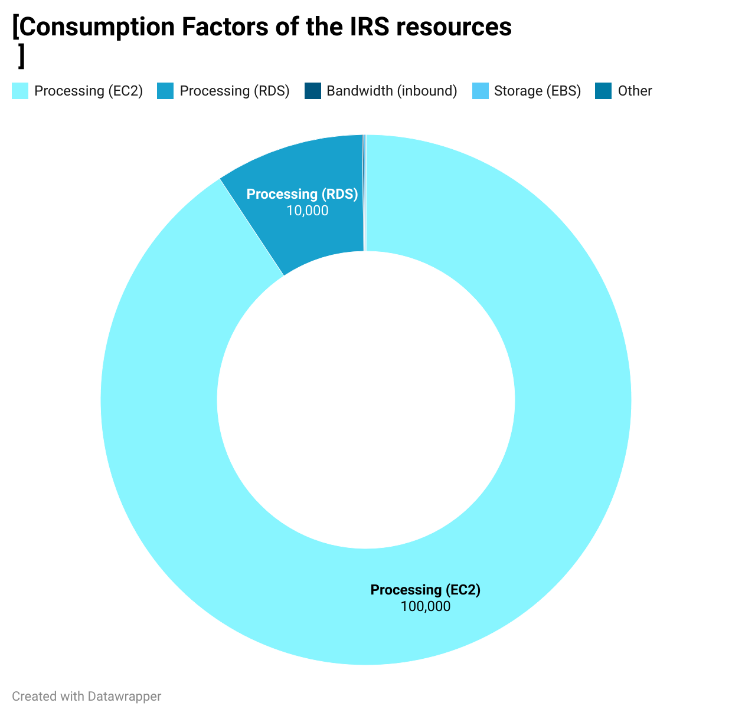

**Three-tier architecture model for IRS migration to AWS:**

**Application tier:**\* Amazon EC2 instances (scalable, available, secure, and cost efficient)

**Database tier:**\* Amazon RDS (scalable, available, secure, and cost efficient)

**Storage tier:**\* Amazon S3 (scalable, available, secure, and cost efficient)

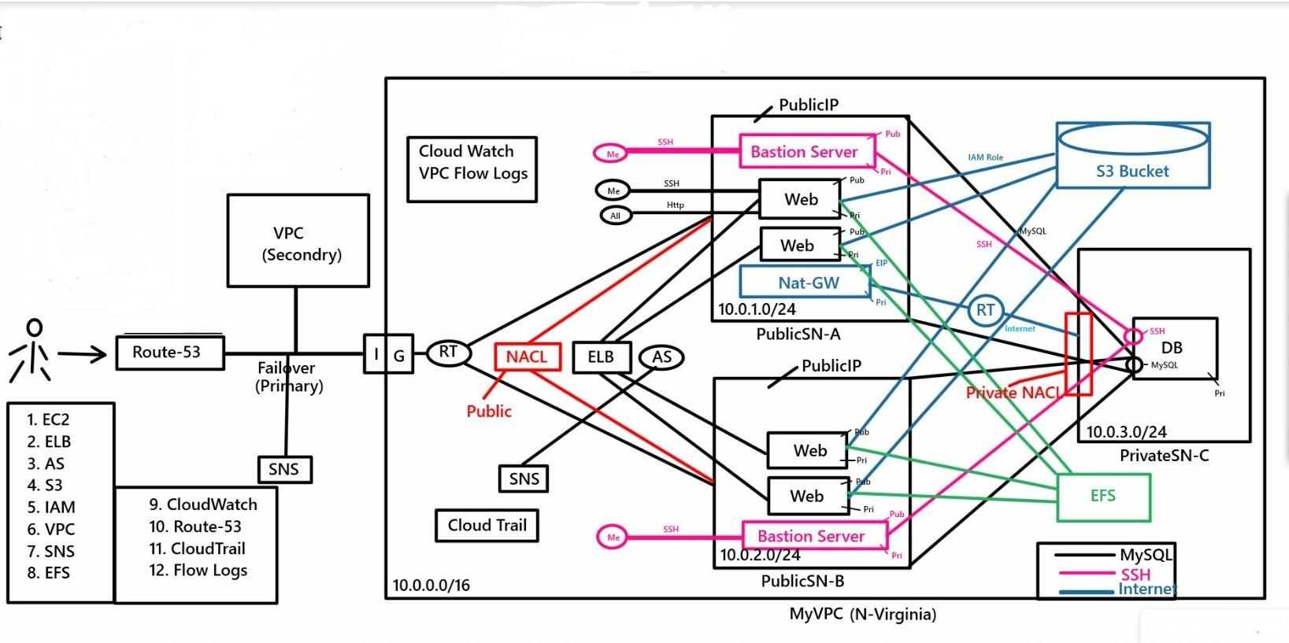

**Scalability:** This model is scalable because each tier can be scaled up or down independently to meet changing demand.

**Availability:** The three-tier architecture model is highly available because each tier is replicated across multiple Availability Zones.

**Security:** This architecture model is secure because each tier has its own security controls to protect data and applications.

**Cost efficiency:** Because AWS offers a variety of pricing options, such as pay-as-you-go pricing and reserved instance discounts.

